Lesson plan 4: Selection
About the lesson
This lesson introduces students to the concept of selection and how selection is used to check something and then do something as a result. It will also build on the concept of variables from the previous lesson and students will begin to use variables to store the results of calculations. Students will perform a series of tasks that demonstrate their understanding of selection in a range of different scenarios.
Learning objectives
By the end of this lesson, students will know how to:
- define selection
- perform calculations using variables
- alter the pathway of a program using selection
- use if-else statements to check a single condition
- use nested if-else statements to check multiple conditions.
National Curriculum
The following subject content from the KS3 National Curriculum is included in this lesson:
- Use two or more programming languages, at least one of which is textual, to solve a variety of computational problems.
- Design, use and evaluate computational abstractions that model the state and behaviour of real-world problems and physical systems.
Links
There are links to English and the need for precise instructions that are carried out in order. There are also links to maths and basic calculations.
Key terminology
selection, if statement, if-else statement, variable
Teaching and learning activities
Share the objectives for the lesson with students (Slide 2 of Lesson 4 presentation).
Starter
Ask students to complete Activity 4.1: Single condition selection (Slide 3, Interactive 4.1).
This activity will enable you to assess students' ability to work out how selection works prior to any formal teaching. It is a self-marking quiz, and you could turn it into a competition to see who gets the most correct answers.
Part 1
Recap the three programming constructs and explain that the focus is shifting to selection (Slide 4 and page 48).
Make sure students understand that although they will be moving on from sequencing to look at selection, their programs will still make use of sequencing.
Explain what selection is and how it works (Slides 5–7 and page 48).
Show students how selection works in Scratch (Video 4.1).
Ask students to complete Activity 4.2: Social media sign up (Page 48/Worksheet 4.2, plus Evidence document 4 and Slide 8).
There is a GIF in the presentation to show students what should happen when they run their program.
Example answers
(See screenshot below and Activity 4.2 solution)
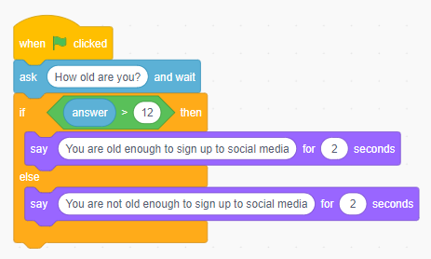
Ask students to complete Activity 4.3: Savings (Pages 47–49/Worksheet 4.3, plus Evidence document 4 and Slide 9).
There is a GIF in the presentation to show students what should happen when they run the program. The activity also contains extension activities.

Example answers
(See screenshot below and Activity 4.3 solution)
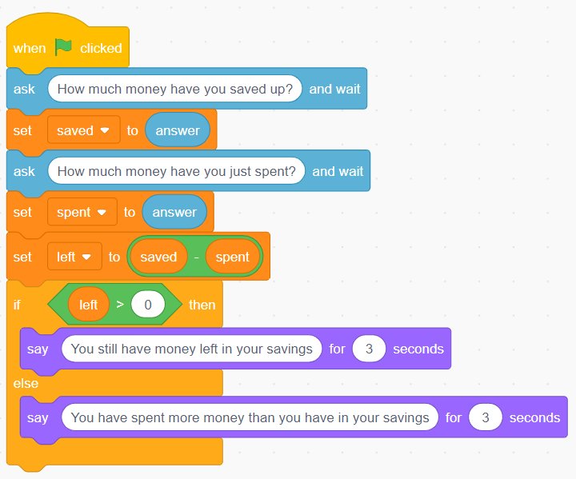
Extension activity 1
(See screenshot below and Activity 4.3 Extension 1 solution)
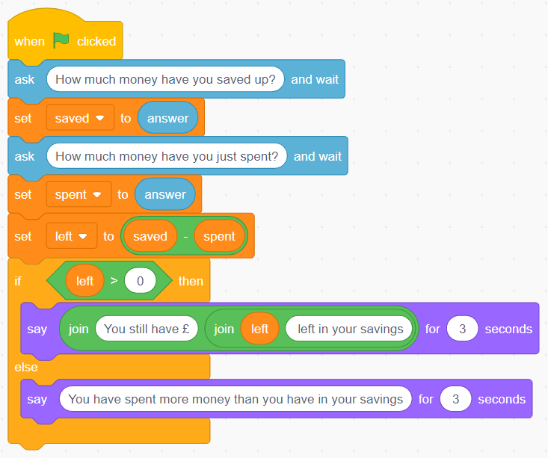
Extension activity 2
(See screenshot below and Activity 4.3 Extension 1 solution)
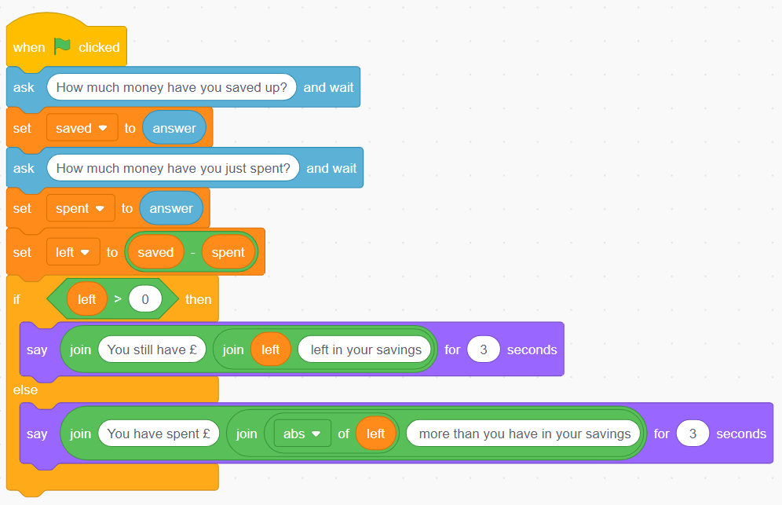
Part 2
Explain how if statements can be nested inside each other to allow for more than one condition to be checked (Slides 10–12 and page 48).
Show students how multiple condition selection works in Scratch (Video 4.2).
Ask students to complete Activity 4.4: Multiple condition selection (Slide 13, Interactive 4.4).
This activity will enable you to check students' understanding of how selection works with multiple if-else statements. It is a self-marking quiz; you could turn it into a competition to see who gets the most correct answers.
Ask students to complete Activity 4.5: Computer game level up (Page 49/Worksheet 4.5, plus Evidence document 4 and Slide 14).
There is a GIF in the presentation to show students what should happen when they run the program. The activity also contains extension activities.

Example answers
(See screenshot below and Activity 4.5 solution)
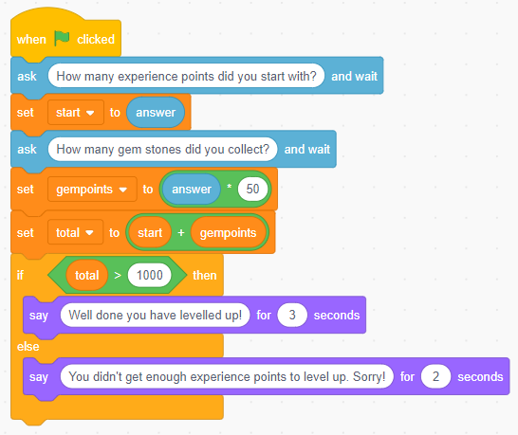
Extension activity 1
(See screenshot below and Activity 4.5 Extension 1 solution)
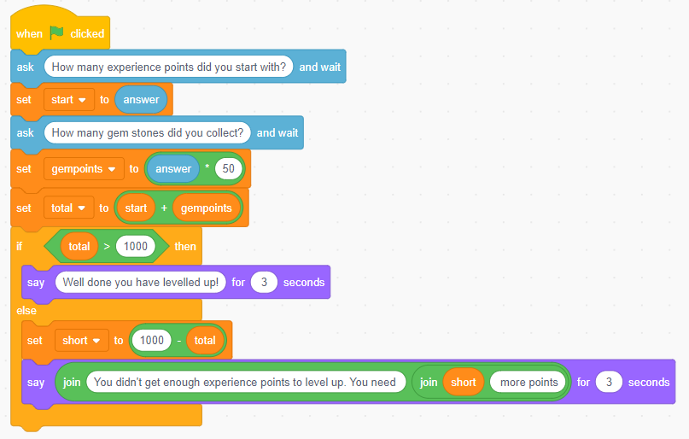
Extension activity 2
(See screenshot below and Activity 4.5 Extension 2 solution)
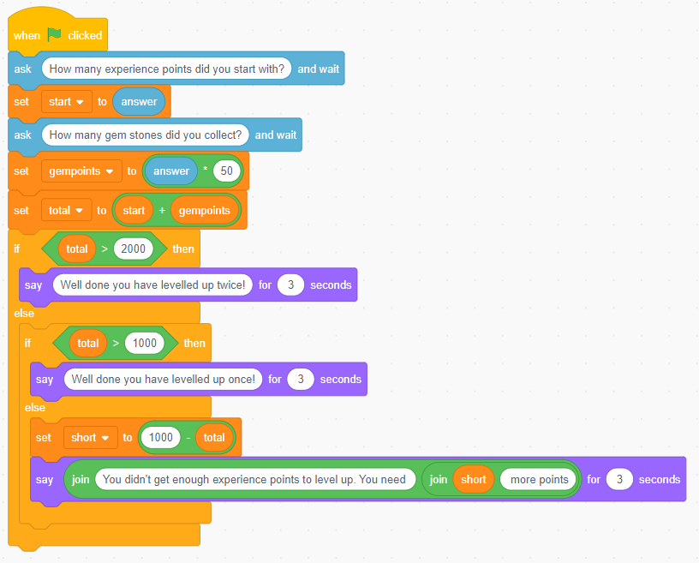
Plenary
Ask students to complete Quiz 4 (Slide 15).
Homework
Ask students to complete any activities they did not finish during the lesson.
Stretch activities
Students who complete the activities in this lesson quickly could be encouraged to extend their programs to nest additional if-else conditional statements so that a variety of response can be checked. They could also add additional variables for other things gained in the game, such as gold coins, which could be included in the conditions for levelling up.
Support activities
Some students may benefit from being given physical versions of the individual code blocks printed out on paper, that they can re-arrange to create the correct program code. This could be done using the examples in the student book. They could be given a checklist for the structure of an if-else statement to help when rearranging the code, which can then be programmed and run via the Scratch website.
There are additional videos about conditional statements in Scratch, such as: www.youtube.com/watch?v=nMRvFeOBkd0 that can be found online via a search engine.

